**Design Principles and Patterns**

**Exercise 1: Implementing the Singleton Pattern**

**Source code**:

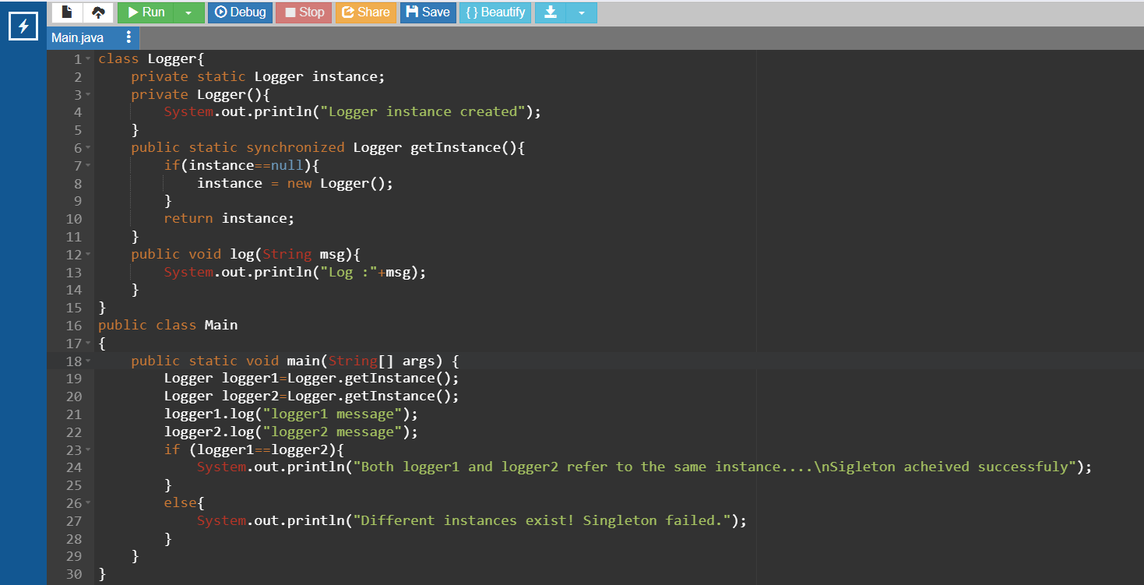

**Output:**

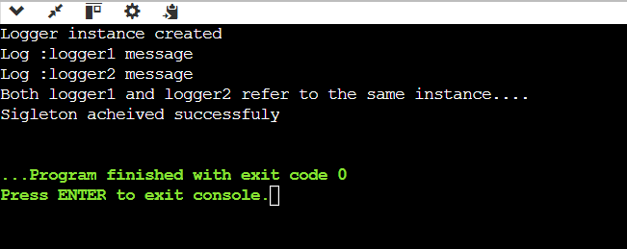

**Design Principles and Patterns**

**Exercise 2: Implementing the Factory Method Pattern**

**Source code:**

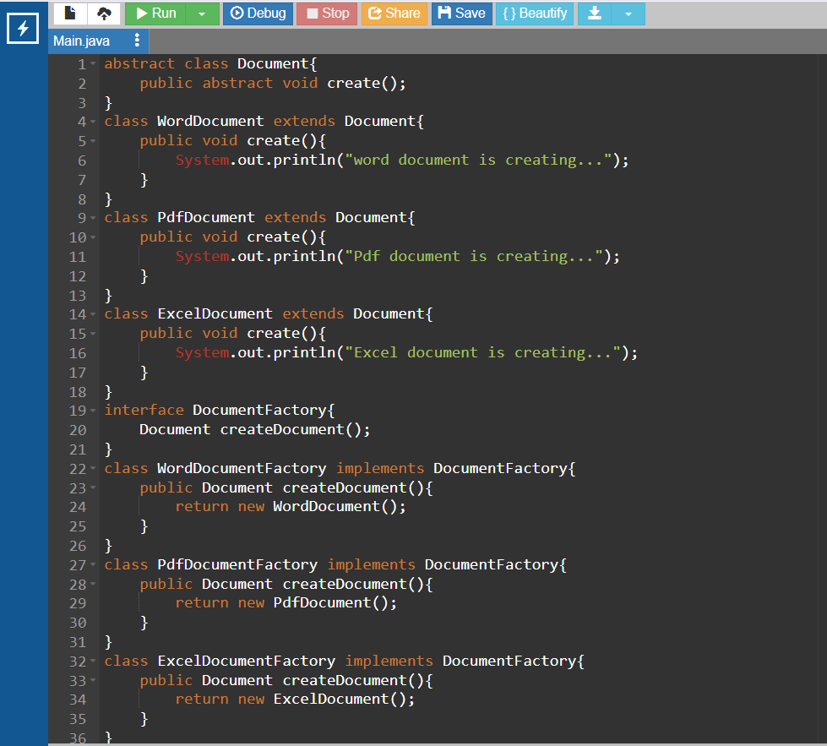

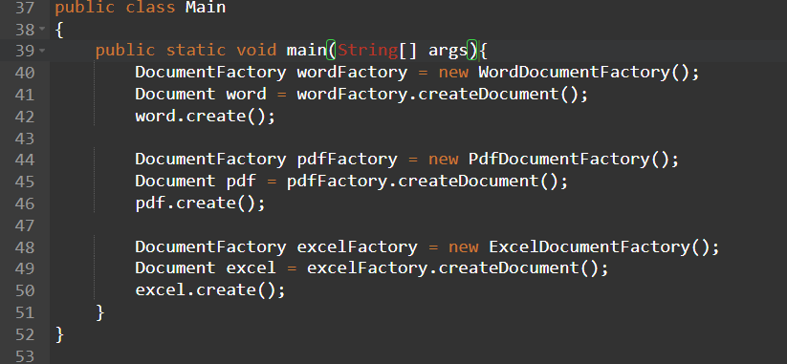

**Output:**

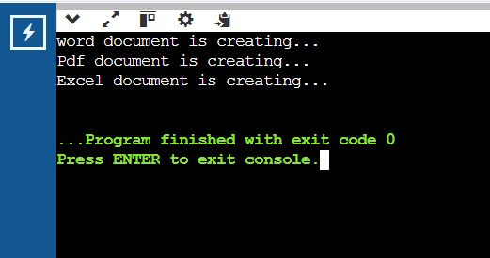

**Data Structures and Algorithms:**

**Exercise 2: E-commerce Platform Search Function**

**Source Code:**

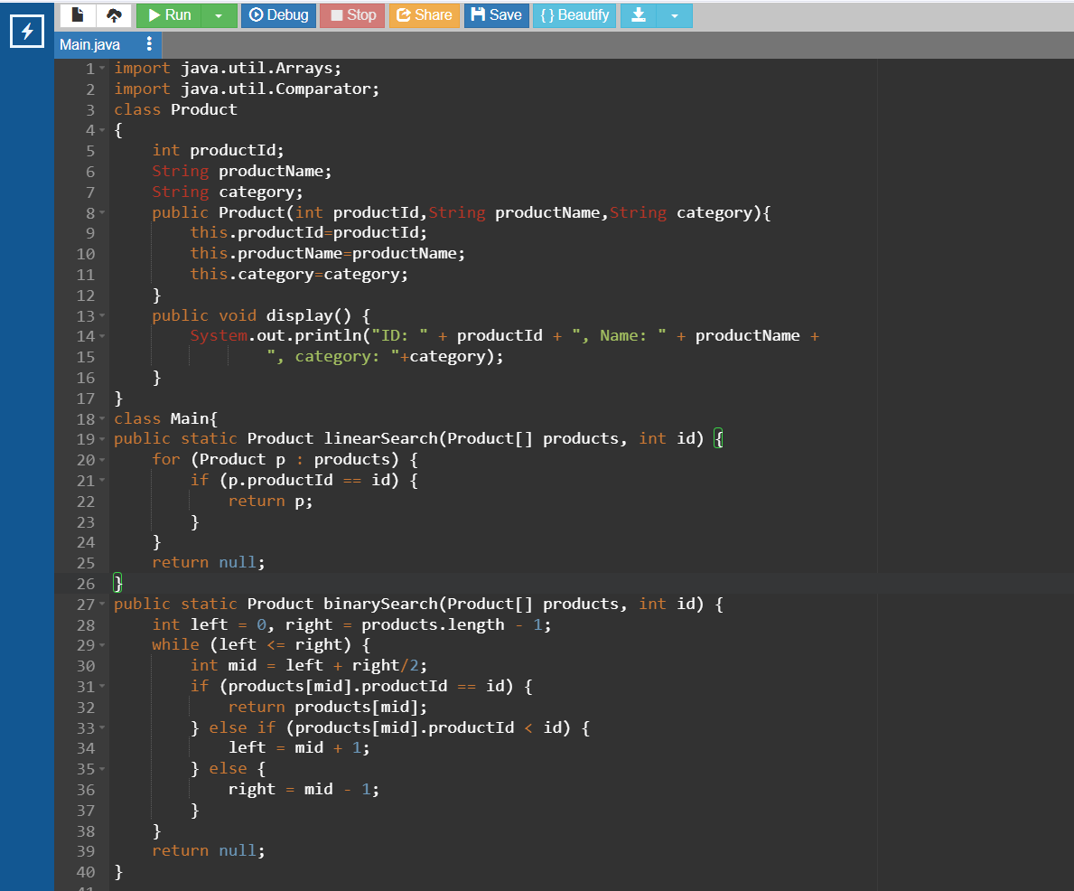

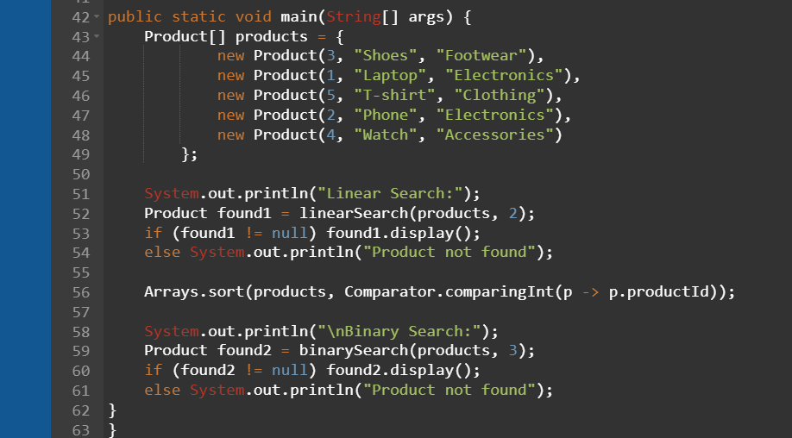

**Output:**

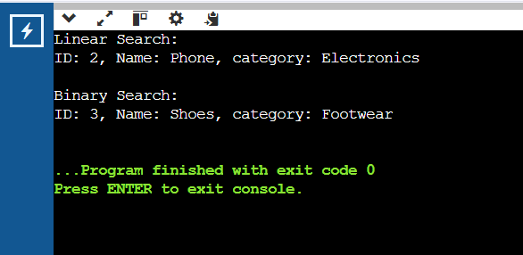

**Exercise 7: Financial Forecasting**

**Source Code:**

